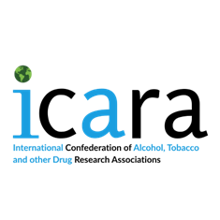
ICARA Board Opportunities 2026-28
Expression of Interest Form
Please note the Board roles up for elections on 23rd April 2026 are: Vice President, Treasurer and up to five ordinary board members.
Personal details
Title:
Name:
Organization:
Other affiliations:
ICARA Board role applying for:
Please declare any conflicts of interest you may have* (e.g. work for alcohol, tobacco, pharmaceutical, gambling, food industries; received money/funding or equivalent from these industries; acted/presented on behalf of these industries):

*Please note that the Board reserves the right to remove expressions of interest where conflicts of interest are declared.

Reasons for applying for this role and to the ICARA board (maximum 500 words)

Please send a copy your CV (maximum 2 pages) and a headshot to icara.international@gmail.com no later than Monday 23rd March 2026.

