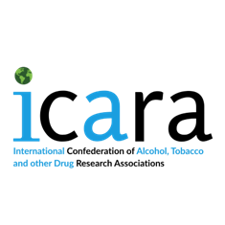
ICARA Board Opportunities 2026-28
Expression of Interest Form
ICARA is seeking new board members, including Vice President, Treasurer and up to five ordinary board members. If you’re interested in one of these roles, please send this completed form and copy or your CV (maximum 2 pages) to icara.international@gmail.com.
Personal details
Title:
Name:
Organization:
Other affiliations:
ICARA Board role applying for:
Please declare any conflicts of interest you may have* (e.g. work for alcohol, tobacco, pharmaceutical, gambling, food industries; received money/funding or equivalent from these industries; acted/presented on behalf of these industries):

*Please note that the Board reserves the right to remove expressions of interest where conflicts of interest are declared.

Reasons for applying for this role and to the ICARA board (maximum 500 words)

